***Online Calculator Link***:

* **Laplace**: <https://www.symbolab.com/solver/calculus-calculator>
* **Inverse Laplace**: <https://www.symbolab.com/solver/inverse-laplace-calculator/inverse%20laplace%20%5Cfrac%7B1%7D%7Bs%5Cleft(s%5E%7B2%7D%2B16%5Cright)%7D%20e%5E%7B-3s%7D?or=input>
* **Integration**: <https://www.symbolab.com/solver/calculus-calculator>
* **Partial Fraction**: <https://www.symbolab.com/solver/partial-fractions-calculator/partial%20fractions%5Cfrac%7B1%7D%7Bs%5Cleft(s%5E%7B2%7D%2B16%5Cright)%7D?or=input>
* **Differentiation**: <https://www.symbolab.com/solver/calculus-calculator>

***Formulae –***

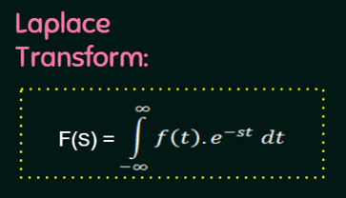

***Laplace Transform of different Input standard signal:***

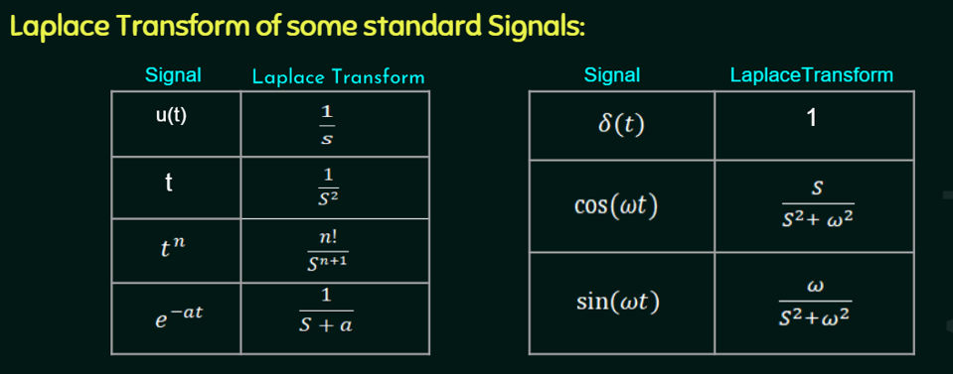

***Steps of calculating Transfer Function from differential equation: Problem given in assignment 1***

* Identify input and output of the system.
* Take Laplace transformation on both side of the differential equation.
* Calculate the ratio of input and output.

***For particular solution:***

***RLC circuit equation:***

* ***Resistor: V = IR or I = V/R***
* ***Capacitor: I=C*dV/dt or V = (1/C)\** ∫I*dt**
* ***Inductor: V = L*dI/dt or I = (1/L)\**** **∫V*dt**

***Poles & Zeros:***

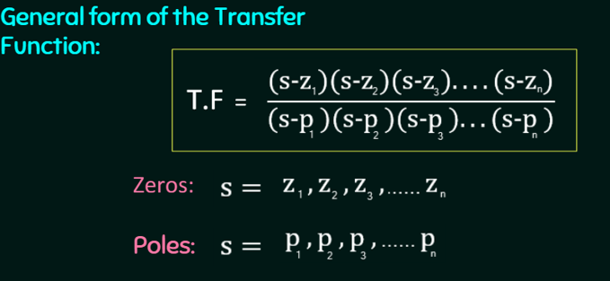

***Open & Closed loop transfer function:***

***Type (Number of poles at origin) & Order(Max power of S at denominator) of any control system:***

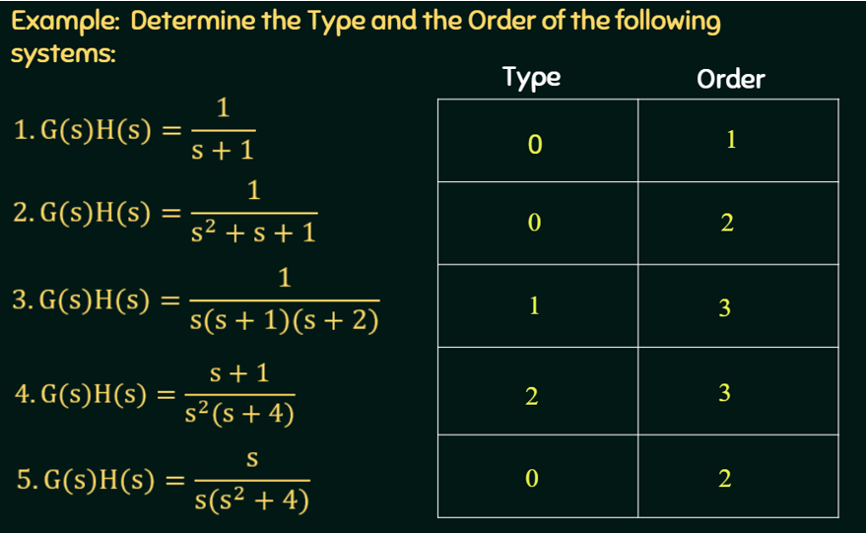

***Note: If any pole of control system is on the RHS side of S plan then final value will be infinite as the system is unstable.***

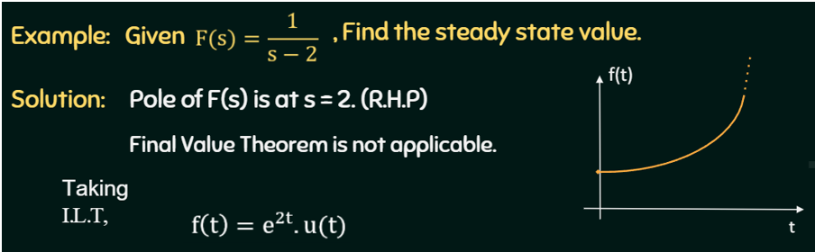

***Time Constant:*** 



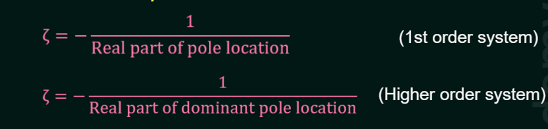



***Corner Frequency:*** Cut-off /Corner frequency (also known as corner frequency or break frequency) is defined as a boundary in a system’s frequency response at which energy flowing through the system begins to be attenuated (reflected or reduced) rather than passing through.

For Example:

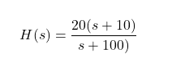*

<https://www.electrical4u.com/cutoff-frequency/#Cutoff-Frequency-from-Transfer-Function>

***DC Gain: Gain of a system at frequency is zero***

***

***Power of S will be the type of system***

***Note: G(S) is not a transfer function it is open loop gain***

***Sensitivity:***

***with respect to parameter K***

***Relationship between step, impulse and ramp signal:***

***General Solution and Particular Solution: Homogeneous and Non-Homogeneous equation solver:***

Final Solution = Complementary Solution + Particular-Solution

* **Complementary solution** can be calculated considering system as homogenous equation. Take Laplace from both end and find a solution for Y(S) and final do Laplace inverse to get y(t)
* **Particular-Solution** can be calculated by considering below table. Based on the right side of the equation general solution can be chosen and then solve for the final answer.

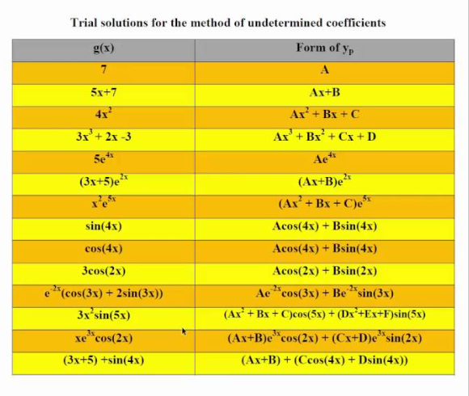

***Time response:***

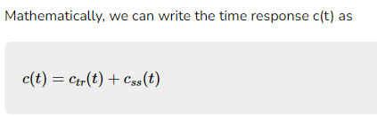

***Second order control system:***

***Graphical representation of transient and steady state response of control system:***

<https://www.tutorialspoint.com/control_systems/control_systems_time_domain_specifications.htm>

***Delay Time:***  It is the time required for the response to reach **half of its final value** from the zero instant. It is denoted by **td**

***Rise Time:*** It is the time required for the response to rise from 0% to 100% of its final value. This is applicable for the under-damped systems. It is denoted by **tr**

***Peak Time:*** It is the time required for the response to reach the peak value for the first time. It is denoted by **tp**

***Peak overshoot:*** Peak overshoot Mp is defined as the deviation of the response at peak time from the final value of response. It is also called the maximum overshoot.

***SettlingTime:*** It is the time required for the response to reach the steady state and stay within the specified tolerance bands around the final value. In general, the tolerance bands are 2% and 5%. The settling time is denoted by ts.

damped frequency ωd, damping ratio δ, natural frequency ωn

***Steady state error:*** The deviation of the output of control system from desired response during steady state is known as steady state error.

***Frequency Domain Specification***:

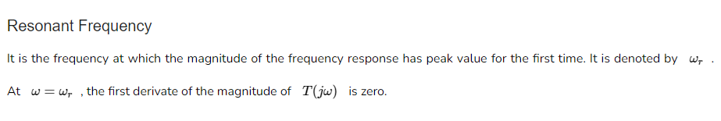

***State Space Modelling:***

1. Differential Equation to State Space
2. Differential Equation to Transfer Function
3. Transfer Function to State Space
4. State Space to transfer Function
5. State Transition Matrix

<https://lpsa.swarthmore.edu/Representations/SysRepTransformations/SysRepTransformations.html>

Refer to solution of assignment 3

1. **Differential Equation to State Space**

* Make the differential equation transform to state equation format to compare for A and B matrix
* Make the differential equation transform to output equation format to compare for C and D matrix

1. **Differential Equation to Transfer Function**
   * Take Laplace transformation on both side of differential equation.
   * Then find the ratio of output in S domain and input in S domain
2. **Transfer Function to State Space** 
   * Convert transfer function to differential equation format.
   * Make the differential equation transform to state equation format to compare for A and B matrix
   * Make the differential equation transform to output equation format to compare for C and D matrix
3. **State Space to transfer Function**
   * Find the A, B, C, D matrix by comparing the state and output equation.
   * Apply below formulae,



* + Derivation of the formulae,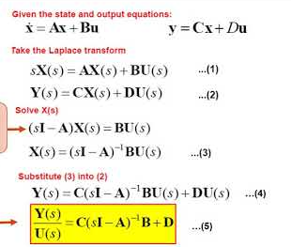

1. **State Transition Matrix**

If A is the given matrix then,

* + Find (SI-A)
  + Calculate inverse of (SI-A) = Φ(s) = Adj(sI-A)/det(sI-A)
  + Take inverse Laplace to find Φ(t) => (Φ(s))

**Coding:**



